**553/1**

**BIOLOGY**

**Paper 1**

**Jul/Aug 2016**

**2 ½ Hours**

**MUKONO EXAMINATIONS COUNCIL**

**Uganda Certi**f**icate of Education**

**BIOLOGY**

**(Theory)**

Paper 1

**2 Hours 30 Minutes**

**INSTRUCTIONS TO CANDIDATES**

* *Answer* ***all*** *questions in section* ***A*** *and* ***B*** *and any* ***two*** *in section* ***C****.*
* *Write answers to questions in section* ***A*** *in the boxes provided.*
* *Answers to questions in section* ***B*** *must be written in the spaces provided.*
* *Answers to questions in section* ***C*** *must be written in the answer booklet provided.*

|  |  |
| --- | --- |
| **For Examiner’s Use only** | |
| **Section** | **Marks** |
| A |  |
| B |  |
| C |  |
| D |  |
| TOTAL |  |

**SECTION A (30 MARKS)**

1. Which one of the following is **not** used to describe the population of organisms?

A. Density B. size

C. Distribution D. Biodiversity

1. Which one of the following sugars is **not** reducing

A. maltose B. fructose

C. sucrose D. galactose

1. Which one of the following hormones stimulates the liver to convert stored glycogen to glucose?

A. Insulin B. Glucagon

C. antidiuretic hormone D. Thyroxine

1. Which of the following is formed during anaerobic respiration in a yeast cell?

A. lactic acid and carbon dioxide B. lactic acid and energy

C. ethanol and carbon dioxide D. water and lactic acid

1. Which one of the following consist of correct responses to cold in a mammal?

A. vasoconstriction, hairs raise

B. increased metabolic rate, hairs lying flat

C. increased smeating, hairs raised

D. vasodilation, hairs raised

1. Which one of the following tissues is responsible for increase in girth in dicotyledonous plants?

A. xylem B. phloem C. cambium D. cortex

1. Which of the following cells detect changes in the environment?

A. Gland cells B. Muscle cells

C. Nerve cells D. Receptor cells

1. The diagram in figure 1 below shows part of nephron of a mammalian kidney.

Glomerulus

X

Fig 1

Which of the following pairs consists of substances absent in part X?

A. red blood cells and plasma proteins

B. plasma proteins and white blood cells

C. white blood cells and urea

D. urea and water

1. When a foetus receives antibodies from the mother through the placenta, it acquires;

A. active immunity B. long term immunity

C. passive immunity D. artificial immunity

1. Worker bees are

A. sterile males developed from unfertilized eggs

B. sterile females developed from unfertilized eggs

C. fertile males developed from unfertilized eggs

D. fertile females developed from unfertilized eggs

1. Bones are attached to muscles by

A. cartilage B. tendons

C. muscle fibres D. ligaments

1. Which one of the following blood vessels carries blood with the highest amount of nutrients?

A. Venacava B. Hepatic vein

C. Pulmonary vein D. Hepatic portal vein

1. Which one of the following is a distinguishing feature of a thoracic vertebra?

A. long neural spine B. large centrum

C. small neural canal D. a pari of large transverse processes

1. An insects respiratory system consists of

A. bronchioles, trachea, tracheoles

B. tracheoles, trachea, spiracles

C. spiracles, trachea, bronchioles

D. tracheoles, trachea, brondhioles

1. Which one of the following cell structures is found in both plant and animal cells?

A. Chloroplast B. middle lamella

C. nucleus D. flagellum

1. In estimating the population of Tilapia fish in a fish pond, 60 fish were captured, marked and released. After 4 days, 50 were captured and out of which 10 were marked. The population of Tilapia in the pond was.

A. 300 B. 400 C. 200 D. 100

1. The graph in figure 2 below shows how body temperature of a cat and a chameleon vary with environmental temperature.

Chameleon

Body temperature

Cat

Environmental temperature

**Fig 2**

Which one of the following is demonstrated in the figure

A. Body temperature of a cat is dependent on environmental temperature

B. Body temperature of a chameleon is dependent on environmental temperature.

C. A cat has a higher body temperature than a chameleon

D. A chameleon loses more heat than a cat.

1. Which of the following sequences represents a correct life cycle of the insect?

A. egg maggot adult : housefly

B. egg caterpillar nymph adult : butterfly

C. egg nymph adult : cockroach

D. egg worm adult : termite

1. Which one of the following characteristics is unique to birds?

A. ability to fly B. possession of feathers

C. possession of scales D. ability to lay eggs

1. Gymnosperms are green non-flowering plants that;

A. produce seeds in ovaries

B. produces naked seeds in cones

C. have root-like structure called rhizoids

D. have leaf-like structures called fronds

1. Which one of the following sets consist of hormones produced by the mammalian reproductive organs?

A. follicle stimulating hormone and testosterone

B. progesterone and testosterone

C. oestrogen and luteinsing hormone

D. follicle stimulating hormone and oestrogen

1. The reason why urine of a healthy person does not contain glucose is that;

A. the glomerulus is impermeable to glucose

B. Glucose is used for respiration

C. Glucose is re-absorbed back into blood steam

D. the kidney converts glucose to urea.

1. Meiosis leads to production of

A. two haploid cells B. four diploid

C. two diploid cells D. four haploid cells

1. Which one of the following responses is a directional growth movement?

A. Taxis B. Tropism

C. Reflex action D. Nastic movement

1. Which of the following sequence represents a simple reflex arc?

A. sensory neurone receptor relay neurone motor neuron

B. receptor sensory neurone relay neurone motor neurone effector

C. receptor motor neurone relay neurone sensory neurone effector

D. sensory neuron motor neurone receptor

1. Which one of the following elements is a micro nutrient?

A. copper B. magnesium

C. calcium D. Sulphur

1. Which one of the following is the main growth stage of the housefly?

A. Puparium B. Pupa

C. Newly hatched adult D. Larva

1. In an experiment to determine the percentage of water in a soil sample, the following results were obtained

Mass of fresh soil = 220g

Mass of soil after heating to constant weight = 198g

What was the percentage of water content in the fresh soil?

A. 10% B. 20% C. 80% D. 90%

1. What type of eye defect is being illustrated in the figure 3 below

**Fig 3**

A. short sight B. long sight

C. Cataract D. Astigmatism

1. Which part of the ear is responsible for detection of the position of the body when the body is rotating?

A. Perilymph B. Cochlea

C. Semicircular canals D. Ossicles

**SECTION B**

1. In an experiment, Fresh green pepper strips were placed in sucrose solutions of varying concentrations to investigate the changes in mass. The strips, each measuring 4cm x 0.5cm, were cut from the wall of the fruit. A total of 18 strips were cut and the mass of each determined. Three strips were then placed in each of the following sucrose solutions; 0.2, 0.4, 0.6, 0.8 and 1.0 mol/dm3, respectively. The remaining three were placed in distilled water. All the strips were left for 30 minutes and then removed and were reweighed. The mean mass of each group of three strips was calculated. The results were recorded on the table 1 below.

|  |  |  |  |  |
| --- | --- | --- | --- | --- |
| **Molarity of sucrose (moldm3)** | **Mean mass in g** | | **Change in mass** | **Percentage change** |
| At the beginning | After 30 mins |  |  |
| 0.0 | 1.74 | 1.83 |  |  |
| 0.2 | 1.47 | 1.46 |  |  |
| 0.4 | 1.45 | 1.35 |  |  |
| 0.6 | 1.52 | 1.34 |  |  |
| 0.8 | 1.80 | 1.53 |  |  |
| 1.0 | 1.38 | 1.15 |  |  |

**Table 1**

a) Calculate the change in mass and the percentage change for each strip. Record the

information in the table 1 above. ***(06marks)***

……………………………………………………………………………………………………………………………………………………………………………………………………………………………………………………………………………………………………………………………………………………………………………………………………………………………………………………………………………………………………………………………………………………………………………………………………………………………………………………………………………………………………………………………………………………………………………………………………………………………………………………………………………………………………………………………………………………………………………………………………………………………………………………………………………………………………………………………………………………………………………………………………………………………………………………………………………………………………………………………………………………………………………………………………………………………………………………………………………………………

…………………………………………………………………………………………………………………………………………………………………………………………………………………………………………………………………………………………………………………………………………………………………………………………………………………………………………………………………………………………………………………………………………

b) Plot a graph of variation of percentage charge in mass with molarity of sucrose

solution. ***(06marks)***



c) From your graph, determine the molarity of sucrose solution that is isotonic to the

pepper tissue. Give a reason. ***(02marks)***

…………………………………………………………………………………………………………………………………………………………………………………………………………………………………………………………………………………………………………………………………………………………………………………………………………………………………………………………………………………………………………………………………………

d) Account for the percentage change in mass when the molarity of sucrose was;

(i) 0.0mol/dm3 ***(03marks)***

……………………………………………………………………………………………………………………………………………………………………………………………………………………………………………………………………………………………………………………………………………………………………………………………………………………………………………………………………………………………………………………………………………………………………………………………………………………………………………………………………………

(ii) 1.0mol/dm3 ***(02marks)***

…………………………………………………………………………………………………………………………………………………………………………………………………………………………………………………………………………………………………………………………………………………………………………………………………………………………………………………………………………………………………………………………………………

1. The diagram below shows a vertical section through a mammalian heart.

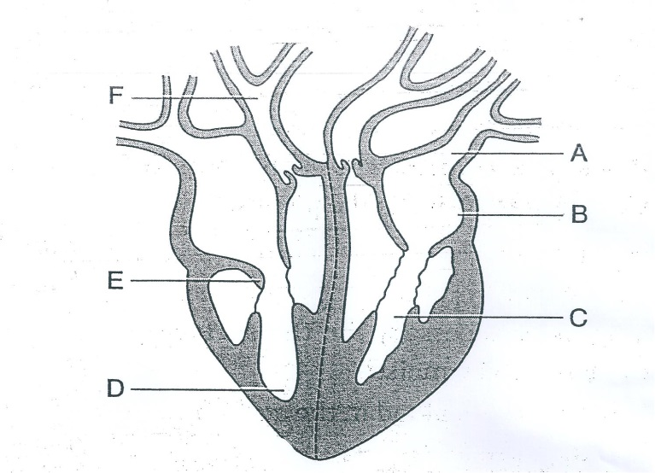

a) Name the parts labelled A, B, E and F ***(02marks)***

A…………………………………………………………………………………………………………………………………B…………………………………………………………………………………………………………………………………E…………………………………………………………………………………………………………………………………F…………………………………………………………………………………………………………………………………

b) Using arrows, show the direction in which blood flows in the heart. ***(02marks)***

c) Explain the difference in the thickness of the walls of chamber C and D ***(03marks)***

…………………………………………………………………………………………………………………………………

…………………………………………………………………………………………………………………………………………………………………………………………………………………………………………………………………………………………………………………………………………………………………………………………………………………………………………………………………………………………………………………………………………

d) Describe two factors that affect the rate of heart beat. ***(03marks)***

……………………………………………………………………………………………………………………………………………………………………………………………………………………………………………………………………………………………………………………………………………………………………………………………………………………………………………………………………………………………………………………………………………………………………………………………………………………………………………………………………………

1. The diagram in figure 4 below represents a common mould.

Q

R

Stolon

Rhizoid

P

a) Identify the kingdom to which the bread mould belongs? ***(01mark)***

…………………………………………………………………………………………………………………………………

b) Name the parts labelled Q and R ***(02marks)***

Q…………………………………………………………………………………………………………………………………R…………………………………………………………………………………………………………………………………

c) (i) Name the mode of nutrition exhibited by the mould. ***(01mark)***

…………………………………………………………………………………………………………………………………

(ii) Explain how are the hyphae of the mould adapted for their function. ***(04marks)***

…………………………………………………………………………………………………………………………………

…………………………………………………………………………………………………………………………………………………………………………………………………………………………………………………………………………………………………………………………………………………………………………………………………………………………………………………………………………………………………………………………………………

d) From the figure above, name the mode of reproduction in the bread mould. Give a reason for your answer. ***(2marks)***

Type:………………………………………………………………………………………………………………………..

Reason:………………………………………………………………………………………………………………………………………………………………………………………………………………………………………………………….

**SECTION C (30MARKS)**

1. a) What is the meaning of the following genetic terms? ***(02marks)***

(i) recessive alleles

(ii) codominant alleles

b) A red cow was mated with a white bull. All the F1 generation calves were all roan.

(i) Using suitable symbols, work out the genotypes of the F1 generation. ***(06marks)***

(ii) If the calves were interbred, determine the phenotypic and genotype ratios.

***(04marks)***

c) Give three practical applications of genetics. ***(03marks)***

1. a) Distinguish between hypogeal and epigeal germination. ***(03marks)***

b) State the role of three external factors necessary for germination. ***(03marks)***

c) Describe an experiment to show that oxygen is necessary for germination.***(09marks)***

1. a) Explain how action of muscles bring about flight in birds. ***(07marks)***

b) Outline adaptations of birds for locomotion in air. ***(08marks)***

1. a) What is meant by environmental degradation? ***(02marks)***

b) Outline the human activities that cause degradation of soil environment. ***(08marks)***

c) Suggest five ways of preventing pollution of an aquatic environment in your locality.

***(05marks)***

***End -***